SQL LAB ASSINMENT -2

MITHUN.K (7152113065)

DATE : 08-08-2024

1) CREATE AND RETRIEVE ALL COLUMNS FROM SALES TABLE

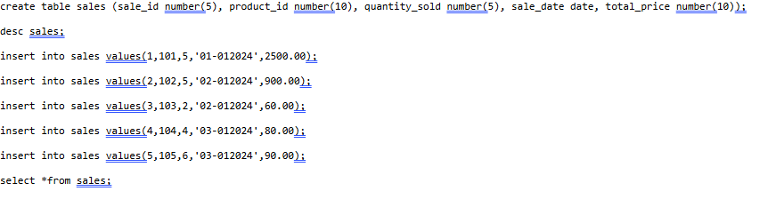

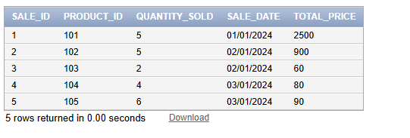

2) RETRIEVE SALE_ID AND QUANTITY_SOLD FROM SALES TABLE.



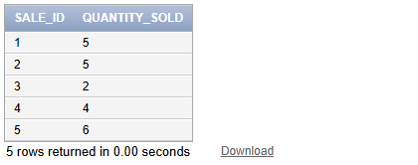

3) RETRIEVE SALE_ID AND SALE_DATE FROM THE SALES TABLE.



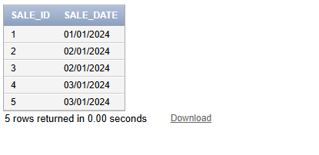

4) FILTER THE SALES TABLE TO SHOW ONLY SALES WITH A TOTAL_PRICE GREATER THAN $100.



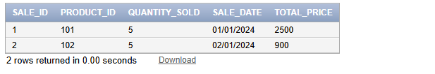

5) RETRIEVE THE SALE_ID AND TOTAL_PRICE FROM THE SALES TABLE FOR SALES MADE ON JANUARY 3, 2024.



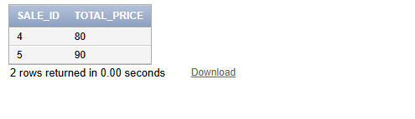

6) RETRIEVE THE SALE_ID, PRODUCT_ID, AND TOTAL_PRICE FROM THE SALES TABLE FOR SALES WITH A QUANTITY_SOLD GREATER THAN 4.



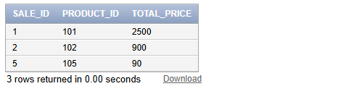

7) RETRIEVE ALL COLUMNS FROM THE SALES TABLE THOSE SALE_ID ARE 1, 3 & 5.



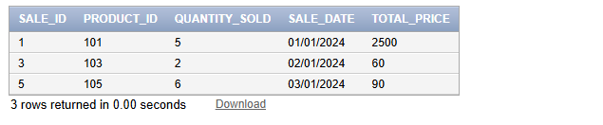

8) RETRIEVE ALL COLUMNS FROM THE SALES TABLE THOSE TOTAL_PRICE BETWEEN 90 AND 1000.



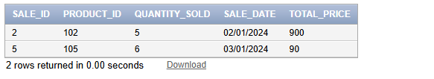

9) RETRIEVE ALL COLUMNS FROM THE SALES TABLE THOSE TOTAL_PRICE NOT BETWEEN 90 AND 1000.



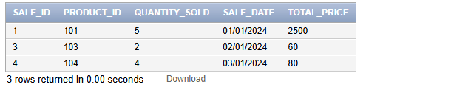

10) RETRIEVE ALL COLUMNS FROM THE SALES TABLE THOSE SALE_ID ARE NOT IN 1, 3 & 5.



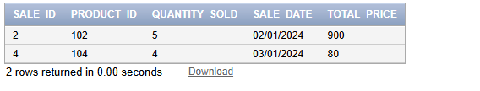

11) UPDATE TOTAL_PRICE AS 500 IN THE SALES TABLE THOSE SALE_ID ARE 1, 3 & 5.



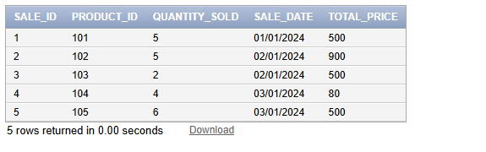

12) DELETE FROM THE SALES TABLE THOSE TOTAL_PRICE NOT BETWEEN 90 AND 1000.



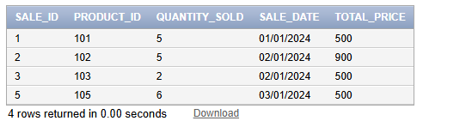

13) SORT ALL THE RECORDS USING SALE_ID COLUMN IN ASCENDING ORDER.



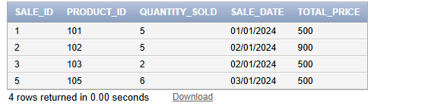

14) SORT ALL THE RECORDS USING SALE_ID COLUMN IN DESCENDING ORDER.



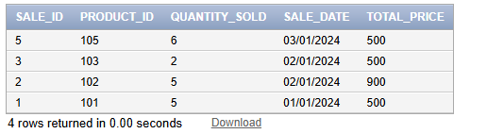

15) RENAME THE SALE_ID COLUMN AS SALES_ID.



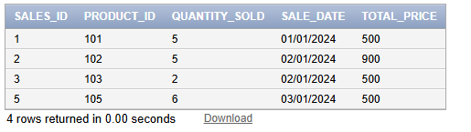

16) DROP THE COLUMN SALES_ID.



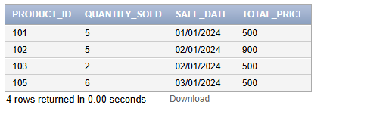

17) RENAME THE TABLE AS TBL_SALES.



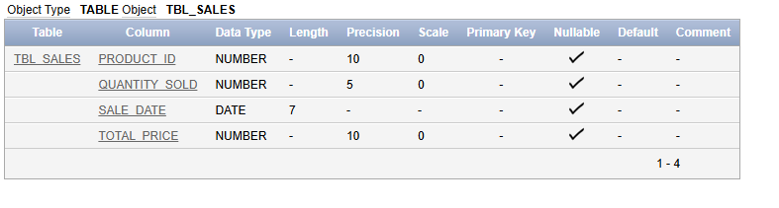

18) DROP THE TABLE.



